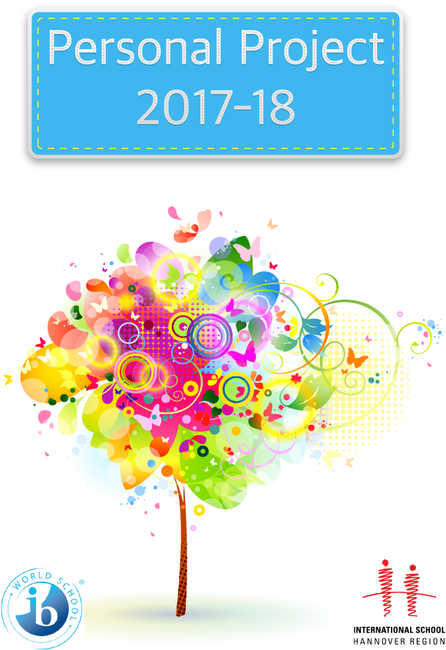Personal Project Handbook 2017-18

Supervisor:

Name:

Contents

|  |  |
| --- | --- |
| What is the personal project? | 3 |
| Personal Project Timeline | 4 |
| Submission A – Criterion A (Investigating) | 5 |
| Submission B – Criterion B (Planning) | 7 |
| Submission C – Criterion C (Taking Action) | 9 |
| Submission D – Writing the report | 11 |
| Submitting the final report | 12 |
|  |  |
| Appendix 1 – Global contexts | 13 |
| Appendix 2 – Creating a project goal | 14 |
| Appendix 3 – Providing evidence of ATL skills | 15 |
| Appendix 4 – What is a process journal? | 16 |
| Appendix 5 – Sample process journal entry | 18 |
| Appendix 6 – Making an effective plan | 19 |
| Appendix 7 – Creating your criteria | 21 |
| Appendix 8 – Tips for report writing | 23 |
| Appendix 9 – Personal Project assessment criteria | 25 |
| Appendix 10 – Sample PP reports | 29 |
|  |  |

n

What is the Personal Project?

“The personal project provides an excellent opportunity for students to produce a truly personal and often creative product/outcome and to demonstrate a consolidation of their learning in the MYP.”

*IB Projects Guide*

The personal project is undertaken in the last year of the MYP gives you the opportunity to show your understanding of the MYP (subject knowledge, global contexts, approaches to learning) by engaging in an inquiry of your own choosing. The diagram below shows the separate parts of your personal project and how you will be assessed:

These elements of the project are assessed using the following 4 criteria:

Criterion A – Investigating

Criterion B – Planning

Criterion C – Taking Action

Criterion D – Reflecting

|  |  |
| --- | --- |
| Process journal | *Extracts of your journal are used to show how you have developed key ATL skills. Assessed in Criterion A, B and C.* |
| Product/Outcome | *The product is self-assessed using criteria that you developed. This self-assessment forms part of the level awarded for Criterion B.* |
| Report | *This report, structured using the criteria, is where most of your levels are found. All four criteria will draw upon what you write here.* |
| Exhibition | *Not assessed* |

The project will be completed **independently**, outside of your classroom time at school. A **timeline** of what you have to do and when you need to do it will be on ManageBac with separate to-do lists for each stage. You will submit notes to your allocated **supervisor** for each stage of the project, culminating in a draft and final version of your report.

Personal Project Timeline

The best and most up-to-date place to check your deadlines is on **ManageBac**. Here you will see the deadlines in your Projects homepage and on the Grade 10 calendar. Any changes made through the year will be updated online.

However, here is a general overview of the key dates you need to know about:

|  |  |  |  |  |  |  |
| --- | --- | --- | --- | --- | --- | --- |
| **August ‘17** | | | | | | |
| **Su** | **M** | **Tu** | **W** | **Th** | **F** | **S** |
|  |  | **1** | **2** | **3** | **4** | **5** |
| **6** | **7** | **8** | **9** | **10** | **11** | **12** |
| **13** | **14** | **15** | **16** | **17** | **18** | **19** |
| **20** | **21** | **22** | **23** | **24** | **25** | **26** |
| **27** | **28** | **29** | **30** | **31** |  |  |
|  |  |  |  |  |  |  |

|  |  |  |  |  |  |  |
| --- | --- | --- | --- | --- | --- | --- |
| **September ‘17** | | | | | | |
| **Su** | **M** | **Tu** | **W** | **Th** | **F** | **S** |
|  |  |  |  |  | **1** | **2** |
| **3** | **4** | **5** | **6** | **7** | **8** | **9** |
| **10** | **11** | **12** | **13** | **14** | **15** | **16** |
| **17** | **18** | **19** | **20** | **21** | **22** | **23** |
| **24** | **25** | **26** | **27** | **28** | **29** | **30** |
|  |  |  |  |  |  |  |

|  |  |  |  |  |  |  |
| --- | --- | --- | --- | --- | --- | --- |
| **October ‘17** | | | | | | |
| **Su** | **M** | **Tu** | **W** | **Th** | **F** | **S** |
| **1** | **2** | **3** | **4** | **5** | **6** | **7** |
| **8** | **9** | **10** | **11** | **12** | **13** | **14** |
| **15** | **16** | **17** | **18** | **19** | **20** | **21** |
| **22** | **23** | **24** | **25** | **26** | **27** | **28** |
| **29** | **30** | **31** |  |  |  |  |
|  |  |  |  |  |  |  |

|  |  |  |  |  |  |  |
| --- | --- | --- | --- | --- | --- | --- |
| **November ‘17** | | | | | | |
| **Su** | **M** | **Tu** | **W** | **Th** | **F** | **S** |
|  |  |  | **1** | **2** | **3** | **4** |
| **5** | **6** | **7** | **8** | **9** | **10** | **11** |
| **12** | **13** | **14** | **15** | **16** | **17** | **18** |
| **19** | **20** | **21** | **22** | **23** | **24** | **25** |
| **26** | **27** | **28** | **29** | **30** |  |  |
|  |  |  |  |  |  |  |

|  |  |  |  |  |  |  |
| --- | --- | --- | --- | --- | --- | --- |
| **December ‘17** | | | | | | |
| **Su** | **M** | **Tu** | **W** | **Th** | **F** | **S** |
|  |  |  |  |  | **1** | **2** |
| **3** | **4** | **5** | **6** | **7** | **8** | **9** |
| **10** | **11** | **12** | **13** | **14** | **15** | **16** |
| **17** | **18** | **19** | **20** | **21** | **22** | **23** |
| **24** | **25** | **26** | **27** | **28** | **29** | **30** |
| **31** |  |  |  |  |  |  |

|  |  |  |  |  |  |  |
| --- | --- | --- | --- | --- | --- | --- |
| **January ‘18** | | | | | | |
| **Su** | **M** | **Tu** | **W** | **Th** | **F** | **S** |
|  | **1** | **2** | **3** | **4** | **5** | **6** |
| **7** | **8** | **9** | **10** | **11** | **12** | **13** |
| **14** | **15** | **16** | **17** | **18** | **19** | **20** |
| **21** | **22** | **23** | **24** | **25** | **26** | **27** |
| **28** | **29** | **30** | **31** |  |  |  |
|  |  |  |  |  |  |  |

|  |  |  |  |  |  |  |
| --- | --- | --- | --- | --- | --- | --- |
| **February ‘18** | | | | | | |
| **Su** | **M** | **Tu** | **W** | **Th** | **F** | **S** |
|  |  |  |  | **1** | **2** | **3** |
| **4** | **5** | **6** | **7** | **8** | **9** | **10** |
| **11** | **12** | **13** | **14** | **15** | **16** | **17** |
| **18** | **19** | **20** | **21** | **22** | **23** | **24** |
| **25** | **26** | **27** | **28** |  |  |  |
|  |  |  |  |  |  |  |

|  |  |  |  |  |  |  |
| --- | --- | --- | --- | --- | --- | --- |
| **March ‘18** | | | | | | |
| **Su** | **M** | **Tu** | **W** | **Th** | **F** | **S** |
|  |  |  |  | **1** | **2** | **3** |
| **4** | **5** | **6** | **7** | **8** | **9** | **10** |
| **11** | **12** | **13** | **14** | **15** | **16** | **17** |
| **18** | **19** | **20** | **21** | **22** | **23** | **24** |
| **25** | **26** | **27** | **28** | **29** | **30** | **31** |
|  |  |  |  |  |  |  |

|  |  |  |  |  |  |  |
| --- | --- | --- | --- | --- | --- | --- |
| **April ‘18** | | | | | | |
| **Su** | **M** | **Tu** | **W** | **Th** | **F** | **S** |
| **1** | **2** | **3** | **4** | **5** | **6** | **7** |
| **8** | **9** | **10** | **11** | **12** | **13** | **14** |
| **15** | **16** | **17** | **18** | **19** | **20** | **21** |
| **22** | **23** | **24** | **25** | **26** | **27** | **28** |
| **29** | **30** |  |  |  |  |  |
|  |  |  |  |  |  |  |

|  |  |
| --- | --- |
| **Key Dates** | |
| Personal Project due dates | June 23rd 2017 – Submission A (Investigating)  September 5th 2017 – Submission B (Planning)  January 9th 2018 – Submission C (Taking action)  February 2nd 2018 – Submission D (Report draft)  March 5th 2018 – Final PP Report due |
| Exhibition | 22nd March 2018 |
| ISHR Holidays | 16th August – 1st day back to school  2nd – 13th October – October break  23rd – 24th November – No school  21st – 5th December/January – Christmas break  12th – 16th February - February break  26th – 6th March/April – Easter break |

Submission A – Criterion A (Investigating)

**Checklist**

* I have written my topic, goal, global context and inquiry question on ManageBac
* I have uploaded my ‘Investigating’ notes to ManageBac
* I have started a process journal and included entries with links to ATLs
* I have met with my supervisor and recorded notes as an Academic Honesty meeting
* My supervisor is happy with the work completed for this stage

**Top-level Criterion A descriptor:**

|  |  |
| --- | --- |
| 7–8 | The student:   1. **defines** a **clear and highly challenging** goal and context for the project, based on personal interests 2. identifies prior learning and subject-specific knowledge that is   **consistently highly relevant** to the project   1. demonstrates **excellent** research skills. |

**Meeting your supervisor:**

It is your responsibility to arrange a time to meet with your supervisor after you have submitted your work. Make sure you bring the following with you to your meeting:

|  |  |
| --- | --- |
| * This ‘Submission A’ document * Your computer | * Your process journal * Something to make notes |

**Recording the Academic Honesty meeting notes:**

The IB require that you complete three ‘Academic Honesty’ meetings throughout the process – one at the beginning, one in the middle and one at the end of the process. As this is the start of the process, you will need to record the notes/feedback from your supervisor’s meeting. Follow these steps:

* 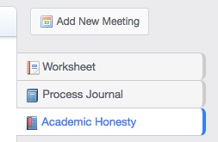On your *Project* tab, click on *Academic Honesty* on the right
* Now click on *Add New Meeting*
* Use the title “AHF Meeting 1”
* Give details of your discussion including what you discussed and the feedback you received.

**Advice and guidance:**

For advice and guidance, see the supporting documents available on ManageBac. Go to the submission date either via the calendar or your Projects homepage.

You can also find the following templates/notes/guides in the Appendix:

* Appendix 1 – Global contexts
* Appendix 2 – Creating a project goal
* Appendix 3 – Providing evidence of ATL skills
* Appendix 4 – What is a process journal
* Appendix 5 – Sample process journal entry

**Submission A: Investigating Notes**

*A copy of this doc is available in editable Word format on ManageBac. Complete it carefully – it will be read by your supervisor and used to see whether you are addressing this criterion. The questions are related directly to criterion A (Investigating) and will need to be answered in your written report later so keep a copy in your process journal.*

|  |  |
| --- | --- |
| **Name** | **Peer Versen** |
| **Project title** | **Creating a Website to inform about and advertise the Kazakhstan Exchange and the country of Kazakhstan.** |

|  |
| --- |
| **Goal** |
| *My goal is to research cultural differences, travel advices and information about the countries in general for Kazakhstan and Germany, to then create a website, which will inform about and advertise the Kazakhstan Exchange.* |
| *My goal is highly challenging, because it requires multiple steps to complete it (research is required to gain the information that will then be on the website, and the creating part, where I will make a website from the beginning). It also adds many different aspects on what to research, and what this research will then inform about.* |
| *I chose this topic/goal because I have been on the Kazakhstan Exchange myself in September 2017, and there was a lot that I didn’t know about the culture. The Kazakh culture is not very well known in Europe and many other countries on the world. This topic should also make the school more open-minded and help to overcome prejudices.* |
| *Here’s what I already know about this topic/goal before I even start the project:*  *I have been on the exchange to Kazakhstan myself, so I have learned and know a lot of information about Kazakhstan and the exchange itself. I will make a list of what I already know before I can even start the project.*   * *The temperatures in Kazakhstan are very instable, since it can get extremely hot in Summer, whereas in Winter it can be very cold, hence the best time to go there for holidays or trips would be some time between Summer and Winter.* * *The country is ten times as large as Germany, which makes it the ninth largest country on the entire Earth. However, although it is this large, it is very unknown or unpopular in the Western world, especially Germany. Also, the country’s population only consists 18 million people (which is not even a fourth of the population of Germany), which shows what a little amount of people live in such a huge country (very low population density)* * *Also, I know that about 2/3 of the entire population are Muslims, and most of the others are Christians. However, with the Muslims and Christians, there are barely any which are very orthodox/religious.* * *The environment in Kazakhstan is mainly divided into 2 terrains: mountains and plains. Most of the country is in the plains biome though. Also, there are not a lot of big cities (only Astana and Almaty have over 1 million inhabitants), while a few cities have over 300,000 inhabitants. Other cities have between 20,000 and 50,000 inhabitants, whereas there are also many small villages with under 100 inhabitants.* * *There are lots of differences between Germany and Kazakhstan in all different areas of everyday life. For example, the main religion is totally different in Germany than it is in Kazakhstan, the environment/landscape is totally different, the population is totally different and the behavior of the people is different.* |
| *I will probably have to use knowledge and skills from these subject areas:*  *Geography – Information about the country of Kazakhstan (its population, geographical location/information and other general information about the country), also for information about the neighboring countries.*  *Comparative Religions – Information about the most common religion in Kazakhstan (Islam), how this is different from the religions that are common here in Germany and how it is similar to other religions.* |

|  |  |
| --- | --- |
| **Global context** | |
| *My chosen global context is…* | |
| * Identities & relationships * Orientation in time & space * Personal & cultural expression | * Scientific & technical innovation * Globalization & sustainability * Fairness & development |
| *Each global context is broken into different areas (see* ***Appendix 1****). Within my global context, I’ll be exploring the following area(s):*   * Beliefs and Values * Human Relationships * Relationships between communities * Access to equal opportunities * Sharing finite resources | *Explain why you have chosen this global context and these focus points. Justify the relevance of your inquiry.*  I have chosen two global contexts, because both of these global contexts fit very well with the goal, that I have created for my Personal Project.  The goalIdentities & Relationships fits very well with my goal, because my website will target the different beliefs and values of the two cultures (Germany and Kazakhstan). It also fits very well, because one of the areas in this global context is Human Relationships, which can be explored very well (in order to find out more about the relationship between the two cultures and countries of Germany and Kazakhstan).  The goal Fairness & Development also fits to my goal very well, since the relationship of Germany and Kazakhstan has not been very good in the past (due to the iron curtain), and now the countries are slowly improving this relationship. Another very important area in the global context Fairness & Development is the Access to equal opportunities, since this is not really the case in Kazakhstan. This is not the case, because there are lots of small villages that are often a few hundred kilometers away from the next town/city. This then prevents the children in these villages to have the same opportunities as the children in the cities/towns (not only because the jobs there are limited, but also because the village schools often do not have the appropriate materials to teach the children in subjects like Biology or Physics). A last very important area in Fairness & Development is the sharing of finite resources. This is a large theme in Kazakhstan, because Kazakhstan owns a quite large percentage of the world’s oil. Kazakhstan does share the oil with other countries, by selling them that oil, however Kazakhstan still keeps lots of oil for itself too, and therefore does not fully share the finite resources that it has too much off. |

|  |
| --- |
| **Product/Outcome** |
| *The product/outcome of my project will be a website to inform about the Kazakh culture and the differences between Kazakhstan and Germany. It should mainly also provide information about the Kazakhstan exchange, so that people might know as much as possible about the exchange, so that they are tempted to apply for it. These two things really fit together, since students could then first look at the information about the exchange, and see if it interests them. If it does interest them, they could then read a short summary or inform themselves a bit more about Kazakhstan, to see what a nice country Kazakhstan is, or if they actually want to go to Kazakhstan. They could then apply for the exchange right on the website and be done with it and hope that they get accepted on going to the trip.* |
| *The product or outcome of my project acts as evidence of meeting my goal/global context because the website will exactly show the cultural differences, travel advices and information about the countries in general (since that will all be a specific part of the website. It will also show a lot and advertise the Kazakhstan Exchange in a specific part.* |

|  |  |
| --- | --- |
| **Process journal / Research** | |
| *Your process journal is where you’ll keep your plans, research, reflections etc. Explain how you plan to…* | |
| *…keep organized:* | I will plan to keep organized by first writing a plan on what entry for the Process Journal I want to have finished by what date (and also plan what the Process Journal Entries will be about beforehand). I will also keep organized, by having all the Process Journal entries in one document, so that I don’t lose all of them in different documents. I will also write myself a deadline on when I should be fully done with the Process Journal. At the end, but before I will start to create the website, to keep my Process Journal organized, I will read through the entire journal to organize it again and highlight the most relevant information. |
| *…link all entries to key ATLs:*  *(see* ***Appendix 3****):* | I will link my Process Journal to key ATL’s, by always before starting to write about something and research in my Process Journal, choosing which ATL skill this entry should link to and be about. I will choose the ATL by thinking about what I will most likely find out during this Process Journal Entry. I might also have to change the link to key ATL’s after I’m done with the entry though, since there might be a different ATL skill that would fit better to this entry. So, at the end of each entry, I will always look over the entry again, to see if there could be any ATL skill that could fit better than the one I chose, and replace that. |
| *…develop your research skills:*  *(what skills will I need to develop/learn)* | I will plan to develop my research skills, mainly by trying multiple different ways of researching for information (internet, newspaper, travel guides, etc.). I will do this by either borrowing books from the library, checking the collections of newspapers that are available on the Internet, or buying travel guides about Kazakhstan and Astana. I will also develop my research skill to select if specific sources are trustworthy, or not (to find out how exactly to trust sources or not, or if websites are biased or objective). |

Submission B – Criterion B (Planning)

**Checklist**

* I have uploaded my ‘Planning’ notes to ManageBac
* I have a **plan** and **criteria** for my product/goal
* I have updated my process journal
* I have met with my supervisor and recorded notes as an Academic Honesty meeting
* My supervisor is happy with the work completed for this stage

**Top-level Criterion B descriptor:**

|  |  |
| --- | --- |
| 7–8 | The student:   1. develops **rigorous** criteria for the product/outcome 2. presents a **detailed and accurate** plan and record of the development process of the project 3. demonstrates **excellent** self-management skills. |

**Meeting your supervisor:**

It is your responsibility to arrange a time to meet with your supervisor after you have submitted your work. Make sure you bring the following with you to your meeting:

|  |  |
| --- | --- |
| * Your plan * Your computer | * Your process journal * Your product/outcome criteria * Something to make notes |

**Recording the Academic Honesty meeting notes:**

The IB require that you complete three ‘Academic Honesty’ meetings throughout the process – one at the beginning, one in the middle and one at the end of the process. As this is near the middle of the process, you will need to record the notes/feedback from your supervisor’s meeting. Follow these steps:

* On your *Project* tab, click on *Academic Honesty* on the right
* Now click on *Add New Meeting*
* Use the title “AHF Meeting 2”
* Give details of your discussion including what you discussed and the feedback you received.

**Advice and guidance:**

For advice and guidance, see the supporting documents available on ManageBac. Go to the submission date either via the calendar or your Projects homepage.

You can also find the following templates/notes/guides in the Appendix:

* Appendix 3 – Providing evidence of ATL skills (see self-management)
* Appendix 6 – Making an effective plan
* Appendix 7 – Creating your criteria

**Submission B: Planning Notes**

*A copy of this doc is available in editable Word format on ManageBac. Complete it carefully – it will be read by your supervisor and used to see whether you are addressing this criterion. The questions are related directly to criterion B (Planning) and will need to be answered in your written report later so keep a copy in your process journal.*

|  |  |
| --- | --- |
| **Name** | **Peer Versen** |
| **Project title** |  |

|  |
| --- |
| **The plan** |
| *My plan covers all aspects of my goal including how I will…* |
| *I have recorded/will record how the plan has been met and/or changes that have been made by…* |

|  |
| --- |
| **The product/outcome criteria** |
| *The criteria I have developed is rigorous because…* |
| *The criteria I have developed addresses the global context because…* |
| *The criteria I have developed covers all aspects of reaching my goal such as…* |

|  |
| --- |
| **Self-management skills (see appendix 3)** |
| *Before I started the project I think I was good at the following self-management skills:* |
| *I have already demonstrated the following new self-management skills during my project and I will show evidence of this in my process journal when I meet with my supervisor:* |
| *I will need to work on strategies to develop the following self-management skills:* |
| *Some initial ideas about what strategies I can use to improve my self-management skills:* |

|  |
| --- |
| **Evidence attached** |
| *I have included below (either copy/pasted or photographed/scanned) the following:*   * *The product/outcome criteria that I developed* * *My personal project plan* |

Submission C – Criterion C (Taking action)

**Checklist**

* I have finished my product/outcome!
* I have uploaded my ‘Taking Action’ notes to ManageBac
* I have updated my process journal
* My supervisor is happy with the work completed for this stage

**Top-level Criterion C descriptor:**

|  |  |
| --- | --- |
| 7–8 | The student:   1. creates an **excellent** product/outcome in response to the goal, global context and criteria 2. demonstrates **excellent** thinking skills 3. demonstrates **excellent** communication and social skills. |

**Meeting your supervisor:**

It is your responsibility to arrange a time to meet with your supervisor after you have submitted your work. Make sure you bring the following with you to your meeting:

|  |  |
| --- | --- |
| * Your product/outcome * Your computer | * Your process journal * Something to make notes |

**Advice and guidance:**

For advice and guidance, see the supporting documents available on ManageBac. Go to the submission date either via the calendar or your Projects homepage.

You can also find the following templates/notes/guides in the Appendix:

* Appendix 3 – Providing evidence of ATL skills (see thinking skills)
* Appendix 3 – Providing evidence of ATL skills (see communication & social skills)

**Submission C: Taking Action Notes**

*A copy of this doc is available in editable Word format on ManageBac. Complete it carefully – it will be read by your supervisor and used to see whether you are addressing this criterion. The questions are related directly to criterion C (Taking action) and will need to be answered in your written report later so keep a copy in your process journal.*

|  |  |
| --- | --- |
| **Name** | **Peer Versen** |
| **Project title** | **Creating a Website to inform about and advertise the Kazakhstan Exchange and the country of Kazakhstan.** |

|  |  |
| --- | --- |
| **Evaluating your product/outcome** | |
| *Complete the following table to evaluate the success of your finished product/outcome based on the criteria that you created and developed through the project. Extend or delete rows as necessary.* | |
| **Criteria** | **To what extent did you meet this criteria?** |
| **Aesthetics** | I have only used two bright colors on my website (only the blue and yellow/orange from the Kazakh flag). However, these are the background, so they make up a lot of the colors that are being used. To conclude, I have not met this part of the criteria very well. I would however say that my website looks very formal, because it is very plain (nothing really crazy or something similar), I have only included facts and personal experience, there is no advertisement on the webpage, the photo and the text are both separated or that I have not talked about politics at all (made my mind about political topics, etc.). However, something that makes the website a little bit less trustworthy or formal is that I have not included a site notice about who has made the website for someone to check for credits. I have fully met the criteria for the form of the website, since I have only used HTML (Hypertext Markup Language) and CSS (Cascading Style Sheets). I have also tried to use some JavaScript, however ended up not using it, due to there being some difficulties to implement JavaScript in HTML. |
| **Cost** | I have managed to host the website for free due to Google Docs being able to host a website free of any charges. Therefore, I have met this criteria perfectly, and even though you can host it for free with Google Docs, there are no downsides to it (nothing like specific functions not working or similar). |
| **Audience** | I believe that I have met this criterion not as well as the other criterions, however I have met this criterion quite well too, because my website is informing about the exchange (which is important for teenagers) and the experiences of our exchange, and the website also has a bit of text about the country (since teenagers wouldn't really read a long text). However, since it is very difficult to target the website at both, parents/teachers and teenagers, I had to make the choice to prefer one over the other. I have chosen teenagers as the main target group, since these would be the actual people that would go onto the exchange, whereas only one teacher would go onto the exchange. I have also made it for parents and teachers a bit though. This website is totally for both ethnicities though, German and Kazakh students can read about this, since it is not very side biased (there is information about both countries), and the only side biased part is the “our experiences” part of the website. |
| **Function** | I believe that I have |
| **Impact** |  |

|  |
| --- |
| **Thinking skills** |
| **Appendix 3** shows the kind of *ATL Thinking Skills* that you might demonstrate in your project. Which of these skills do you think you have developed or learned through this project? |
| I have copied evidence of the following thinking skills from my process journal: (again refer to **Appendix 3**) |

|  |
| --- |
| **Communication & social skills** |
| **Appendix 3** shows the kind of *ATL Communication and Social skills* that you might demonstrate in your project. Which of these skills do you think you have developed or learned through this project? |
| I have copied evidence of the following communication & social skills from my process journal: (again refer to **Appendix 3**) |

|  |
| --- |
| **Evidence attached** |
| *I have included below (either copy/pasted or photographed/scanned) the following:*   * *Evidence of the completed product/outcome (****up to 5 images or 30 seconds of video****)* * *Extracts from your process journal showing ‘Thinking skills’* * *Extracts from your process journal showing ‘Communication/social skills’* |

Submission D – Writing the report

**Checklist**

* I have uploaded the draft of my report
* My report includes 5-10 extracts from my process journal showing ATL skill development
* I have met with my supervisor and recorded notes as an Academic Honesty meeting
* My supervisor is happy with the work completed for this stage

**Top-level Criterion D descriptor:**

|  |  |
| --- | --- |
| 7–8 | The student:   1. presents an **excellent** evaluation of the quality of the product/outcome against his or her criteria 2. presents **excellent** reflection on how completing the project has extended his or her knowledge and understanding of the topic and the global context 3. presents **excellent** reflection on his or her development as an IB learner through the project. |

**Meeting your supervisor:**

It is your responsibility to arrange a time to meet with your supervisor after you have submitted your work. Make sure you bring the following with you to your meeting:

|  |  |
| --- | --- |
| * Your written report * Your computer | * Your process journal * Something to make notes |

**Recording the Academic Honesty meeting notes:**

This is the last time you will need to record the meeting notes as an Academic Honesty meeting on ManageBac. Follow the instructions from previous deadlines to add your final meeting notes titled “AHF Meeting 3”. Aim to include some information from you and your supervisor about how you have developed your skills, knowledge and learning through the project.

**Advice and guidance:**

Your report can be written, electronic (blog, website, etc), oral (podcast, recorded, etc) or visual (film), but we **recommend writing** your report as for most students this is the easiest way to plan, structure, draft and edit your ideas.

Your written report should be **structured using the criteria/objectives** and so should include four sections (Investigating, Planning, Taking action and Reflecting). Within these sections you could use the strands of each criteria as sub-headings to make sure that you address each part of the criteria.

For a more specific breakdown of what to write and how to organize your report see the document on ManageBac titled, *Writing the Report*. Go to the submission date either via the calendar or your Projects homepage.

You can also find the following templates/notes/guides in the Appendix:

* Appendix 8 – Tips for report writing
* Appendix 9 – Personal Project assessment criteria
* Appendix 10 – Sample PP reports

Submitting the Final Report

**Checklist**

* I have uploaded the final copy of my report on ManageBac
* I have uploaded a second copy which is anonymous
* I printed a complete Academic Honesty Form with at least 3 entries
* I have printed two copies of my report/AHF and handed them to my supervisor
* My supervisor has marked my Project as complete!

**Making an anonymous report copy:**

When we submit reports to the IB they need to be completely anonymous. This means that you will have to delete any reference to:

* People’s names
* School names and codes
* Specific place names

When you do this just replace each word with an ‘XXXX’ to show that the word has been deleted.

**Printing the Academic Honesty Form**

When all of your Academic Honesty meeting notes are complete, you can print your Academic Honesty Form, which is required by the IB. Follow these steps:

* Navigate to your *Projects* page and click *Academic Honesty* on the right of the screen
* Click the *Academic Honesty Form* button on the right of your screen
* Save and print the form
* Sign it next to *Student:* for each AH meeting

**…and finally:**

Once you’ve finished you can relax a little and start to think about how you’re going to celebrate your project experience in the exhibition. Well done for finishing and take pride in your work!

Appendix 1 – Global contexts

*The following table shows the global contexts and the areas of possible exploration. You should identify which global context and specifically which area(s) you will explore in your project.*

|  |  |
| --- | --- |
| **Global context** | **Areas to explore** |
| **Identities and relationships**  Who am I? Who are we? | Students could explore…   * Identity * beliefs and values * personal, physical, mental, social and spiritual health * human relationships including families, friends, communities and cultures * what it means to be human |
| **Orientation in time and space**  What is the meaning of ‘where’ and ‘when’? | Students could explore…   * personal histories * homes and journeys * turning points in humankind * discoveries * explorations and migrations of humankind * the relationships between, and the interconnectedness of, individuals and civilizations, from personal, local and global perspectives. |
| **Personal and cultural expression**  What is the nature and purpose of creative expression? | Students could explore…   * the ways in which we discover and express ideas, feelings, nature, culture, beliefs and values * the ways in which we reflect on, extend and enjoy our creativity * our appreciation of the aesthetic (beauty). |
| **Scientific and technical innovation**  How do we understand the worlds in which we live? | Students could explore…   * the natural world and its laws * the interaction between people and the natural world * how humans use their understanding of scientific principles * the impact of scientific and technological advances on communities and environments * the impact of environments on human activity * how humans adapt environments to their needs. |
| **/Globalization and sustainability**  How is everything connected? | Students could explore…   * the interconnectedness of human-made systems and communities * the relationship between local and global processes * how local experiences mediate the global * reflect on the opportunities and tensions provided by world-interconnectedness * the impact of decision-making on humankind and the environment. |
| **Fairness and development**  What are the consequences of our common humanity? | Students could explore…   * rights and responsibilities * the relationship between communities * sharing finite resources with other people and with other living things * access to equal opportunities * peace and conflict resolution. |

Appendix 2 – Creating a project goal

*The criteria tells us that to reach the highest levels we must ‘define a clear and highly challenging goal’. This is the most important part of your project – if you get this right, you’ll be set on a course for success.*

|  |  |  |
| --- | --- | --- |
| **Basic** | **Challenging** | **Highly challenging** |
| I want to make a recycled bag | I will research reusable products to create a durable, reusable bag out of recycled materials for adults | I will research reusable products to create a line of durable, reusable bags out of recycled materials to sell at a local craft market to adults |
| I want to make a photobook | I will research photography techniques to create a photo journal outlining my learning progress | I will research photography techniques to create a photo essay about teenage stress for members of the school community |
| I want to make a kimono | I will research how to design and create a traditional kimono | I will research traditional techniques used to design and create a kimono reflecting my own identity |

|  |  |  |
| --- | --- | --- |
| **Basic goals:**   * tend to focus only on the outcome | **Challenging goals:**   * add an element of how you reach the outcome * give more specific details about the outcome | **Clear and highly challenging goals:**   * add an element of how you reach the outcome * give specific and challenging details about the outcome * consider the audience of your outcome and/or how you will reach them * address the purpose of your outcome – why are you doing/making it? |

You don’t have to use these templates, but here are some possible formulas for creating a good goal:

|  |
| --- |
| **Some goal formulas** |
| I will research _____________________ *[list the skills, knowledge or data needed]* in order to make/ /produce _____________________ *[the final product/outcome]* for _____________________ *[target audience and means of sharing].* |
| I will learn how to _____________________ *[list skills, knowledge or data needed]* so that I can create a _____________________ *[the final product/outcome]* which _____________________ *[give specific details of the product/outcome]* |
| I will design and create a _____________________ *[final product/outcome]* in order to _____________________ *[give the reason why you want to create the product/outcome]* for _____________________ *[your target audience or community]* |
| I will investigate skills of _____________________ *[specific topic area] in order to design and create a* _____________________ *[final product]* to be delivered/presented/shown at_____________________  *[method of presentation/sharing your product].* |

|  |  |  |  |  |  |
| --- | --- | --- | --- | --- | --- |
| **Some useful verbs to consider using in your goal** | | | | | |
| Create | Design | Plan | Build | Invent | Research |
| Learn | Teach | Reflect | Identify | Help | Develop |
| Raise funds | Raise awareness | Change | Improve | Support | Publish |

Appendix 3 – Providing evidence of ATL skills

*Each process journal entry should address one or more of the following ATL skills. These will demonstrate how you have met parts of the criteria. When you write the report, you will need to select a maximum of 10 entries from your process journal which demonstrate that you have developed these 5 ATL skills: Research, Self-management, Thinking, Communication/social, Reflection.*

*These tables show you the kind of things you can do to demonstrate each ATL:*

|  |  |
| --- | --- |
| **Research skills (assessed in Criterion A)** | |
| **Information literacy skills** | **Media literacy** |
| Evidence of information literacy skills may include:   * Collecting, recording and verifying data * Making connections between sources of information * Collecting and analyzing data to identify solutions and make informed decisions * Processing data and reporting results * Evaluating and selecting information sources based on their appropriateness to specific tasks * Using critical literacy skills to analyze and interpret media communications * Creating references and citations, using footnotes/endnotes and constructing bibliography according to recognized conventions | Evidence of media literacy skills may include:   * Locating, organizing, analyzing, evaluating, synthesizing, and ethically using sources from a variety of sources and media * Demonstrating awareness of media interpretations of events and ideas * Seeking a range of perspectives from multiple and varied sources * Communicating information and ideas effectively to multiple audiences using a variety of media and formats * Comparing, contrasting and drawing connections among (multi)media resources |

|  |  |
| --- | --- |
| **Self-management skills (assessed in Criterion B)** | |
| **Organizational skills** | **Affective skills** |
| Evidence of organizational skills may include:   * Having a detailed plan for the completion of the project * Planning strategies/actions to achieve the goal * Meeting deadlines * Keeping an organized and logical process journal * Setting goals that are challenging but realistic * Selecting and using technology effectively and productively | Evidence of affective skills may include:   * Perseverance and persistence * Self-motivation and positive-thinking * Resilience – the ability to deal with mistakes, failures, disappointment, change |

|  |  |  |
| --- | --- | --- |
| **Thinking skills (assessed in Criterion C)** | | |
| **Critical thinking skills** | **Creative thinking skills** | **Transfer skills** |
| Evidence of critical thinking skills may include:   * Recognizing or identifying problems, obstacles or challenges * Formulating arguments * Recognizing assumptions and bias in sources * Interpreting data * Evaluating sources * Drawing reasonable conclusions and generalizations * Revising understanding based on new information * Formulating questions * Considering ideas from multiple perspectives * Proposing and evaluating a variety of solutions | Evidence of creative thinking skills may include:   * Brainstorming or visual diagrams used to generate ideas or inquiries, or visible thinking strategies or techniques * Considering multiple alternatives – even those that may seem impossible * Making unusual connections between ideas or objects * Designing improvements existing technologies * Creating novel solutions or original works and ideas – or using existing works or ideas in new ways | Evidence of transfer skills may include:   * Applying skills and knowledge in unfamiliar situations * Comparing conceptual understanding across multiple subject groups and disciplines * Combining knowledge, understanding and skills to create products or solutions * Transferring current knowledge to learning of new technologies * Changing the context of an inquiry to gain different perspectives |

|  |  |
| --- | --- |
| **Communication and social skills (assessed in Criterion C)** | |
| **Communication skills** | **Collaboration skills** |
| Evidence of communication skills may include:   * Giving and receiving feedback (not necessarily only from their project supervisor) * Using appropriate speaking and written techniques for dealing with different audiences * Negotiating ideas and knowledge with peers, teachers or others (possibly as part of research) * Collaborate and share ideas (may be part of the product) * Make inferences and draw conclusions * Write for different purposes * Paraphrase and take effective notes * Organize and depict information logically * Structure information in the written report | Evidence of social (collaboration) skills may include:   * Demonstrating empathy * Helping others to succeed * Taking responsibility for one’s own actions * Listening actively to perspectives and ideas of others * Giving and receiving meaningful feedback |

|  |
| --- |
| **Reflection skills (assessed in Criterion D)** |
| Evidence of reflection skills may include:   * Developing new skills, techniques or strategies for effective learning * Identifying strengths and weaknesses of personal learning strategies (self-assessment) * Trying new ATL skills and evaluating their effectiveness * Considering increased knowledge and understanding relating to the project topic * Considering ATL skills development * Considering their development as a learner |

Appendix 4 – What is the process journal

*Your process journal is your way to document/record your progress as you go through the project. The following table highlights how you should view the process journal:*

|  |  |
| --- | --- |
| **The process journal is:** | **The process journal is not:** |
| * used throughout the project to document its development * an evolving record of intents, processes, accomplishments * a place to record initial thoughts and developments, brainstorming, possible lines of inquiry and further questions raised * a place for recording interactions with sources, for example teachers, supervisors, external contributors * a place to record selected, annotated and/or edited research and to maintain a bibliography * a place for storing useful information, for example quotations, pictures, ideas, photographs * a means of exploring ideas and solutions * a place for evaluating work completed * a place for reflecting on learning * devised by the student in a format that suits his or her needs * a record of reflections and formative feedback received. | * used on a daily basis (unless this is useful for the student) * written up after the process has been completed * additional work on top of the project; it is part of and supports the project * a diary with detailed writing about what was done * a static document with only one format. |

**Each entry** in your process journal should include the following important elements:

* A date
* A title
* A link to at least one of the 5 ATL skills

When researching or investigating with **primary or secondary sources**, you should also include:

* Source details (for use in a bibliography/works cited)
* Source evaluation (to assess the validity of the source)
* Either a summary of findings or an annotated copy of the source
* Any actions to take as a result or any new questions raised
* If applicable, an evaluation of how it helps you move towards your goal

There are many ways to evaluate a source. Here is one approach you could use:

|  |  |  |  |
| --- | --- | --- | --- |
| **Authority** | **Accuracy** | **Currency** | **Bias** |
| Who is responsible for presenting the information? | Is the information precise? Can it be proven and verified? | How old is this information and is this important? | Is the information based on fact or opinion? Is it only from one point of view? |
| * Who has written the information and can we check their qualifications? * Is the information from an expert in this field? | * Is the information correct? * Can we check the accuracy of the information through links, footnotes or bibliographies? | * When was the information written? * Has the information been revised or updated? | * Who has written the information and can we check their qualifications? * Is the information delivered in an objective way? |

Appendix 5 – Sample process journal entry

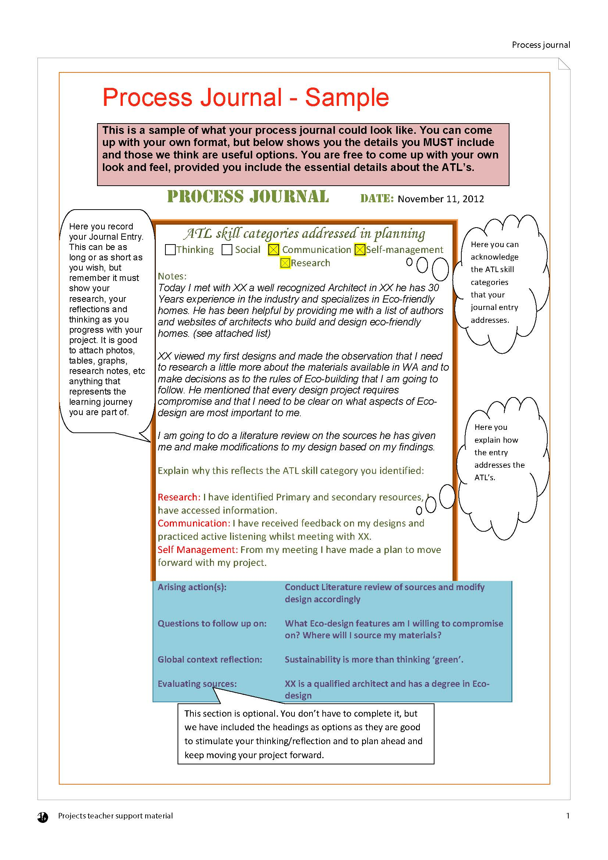

Appendix 6 – Making an effective plan

Your plan is a requirement of the project and is directly assessed in Criterion B. An effective plan must do the following:

* **Detail:** Cover all aspects of how you aim to achieve your goal
* **Order:** Be organized in sequential order where possible
* **Due dates:** Have clear dates for when you plan to complete each component
* **How:** Show how you plan to complete each component
* **Manage progress:** Track your progress against the plan and update where necessary

The first stage of making a plan is trying to break your goal down into the different tasks. A good goal will require many different elements to be considered. Here is an example:

**Goal:** To learn how to weld and use

these skills to create a sculpture that represents my farm.

Research welding techniques

Experiment with practice welding techniques

Find a mentor

Brainstorm designs

Select final design

Have final design reviewed by experts

Source materials

Complete welding introduction course

Once you’ve brainstormed the parts of the project, order them in your plan. You can choose any format to as long as it accomplishes all of the above. Here is an example of one planning format you could use:

|  |  |  |  |
| --- | --- | --- | --- |
| **Action/step** | **When?** | **How?** | **Progress** |
| 1. Find mentor | November 15 | Ask our farm hand. Ask Dad for any contacts. |  |
| 1. Book into TAFE course for December | November 15 | Apply online to Northam TAFE |  |
| 1. Brainstorm design ideas Highlight essential features I want included in my sculpture. | November 30 | Use sketch pad. Search internet for design ideas and inspiration. Use photographs of my farm for inspiration. |  |
| 1. Research Welding Techniques | December 15 | Start with internet search. Look in the library for any books and ask librarian if he has any information. Obtain the support materials to be used on the TAFE course. |  |
| 1. Complete Final Design | December 20 | Have final design sketched and reviewed by my mentor and TAFE tutor. Reviewing joins and materials required. |  |
| 1. Complete welding introduction course. | December 20 | Complete 3 day course at TAFE |  |
| 1. Source materials | January 5 | Locate materials from around the farm ie. scrap. Have my mentor review my final design and note any further materials I will need. |  |
| 1. Experiment with welding | January 7-8 | Using Farm scraps and the farm welder, practice my joins and technique. Book time with my Mentor to observe my technique. |  |
| 1. Complete final design | January 20 | Weld each day for a minimum of two hours until the project is complete. |  |

Other plans might be organized by section or sub-topic like this example:

|  |  |  |  |  |
| --- | --- | --- | --- | --- |
| **Goal:** To design an iPhone app which helps students to improve their time-management at ISHR | | | | |
| **Target** | **What to do** | **How to do it** | **By when** | **Complete?** |
| Investigate the issue of time-management | Track homework and assessments | Ask student in each year level to keep a record over a month | August/September |  |
| Feedback from teachers | Email a range of teachers a questionnaire | September |  |
| Designing the app | Identify key menu options in the app | Analysis of data received from teachers and students | September |  |
| Review related apps on the market | Identify key elements that work well in other time-management apps – record in process journal | October |  |
| Sketch ideal look and organization of app | Hand drawn plan showing links between sections | October |  |
| Review templates or programmes used for coding | Research different options for the creation of the app | October |  |
| Creating the app | Begin building the app | Procedure/tools used depend on investigations in the design. | November/December |  |
| Get feedback on initial look | Give screenshots to students and survey feedback | December/January |  |
| Amend and complete the app | Use inquiry cycle to continue to revise the product. | February |  |
| Publishing the app | Review apple policy on publishing | Research online and contact apple help if necessary | February |  |
| Review third party means of sharing apps | Research online how easy it might be to share the app | February |  |
| Advertise and share the app with the school community | Use posters; speak with students via advisory classes | February |  |

Appendix 7 – Creating your criteria

To get the top level in Criterion B (Planning), you have to “develop **rigorous** criteria for the product/outcome.” The word *rigorous* suggests that your criteria are thorough, demanding, accurate, challenging.

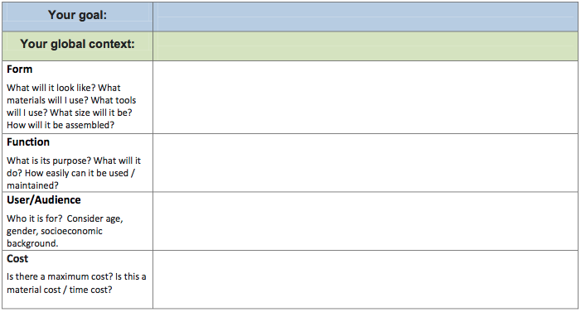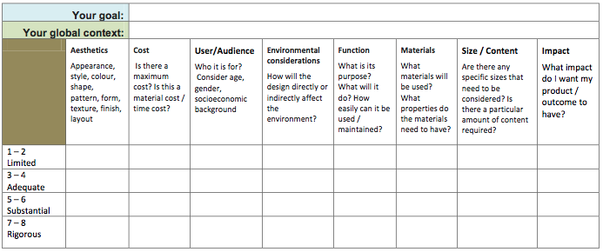You should try to consider all aspects that would demonstrate a successful product/outcome. Here are two different examples you could consider, although you would only use the columns/rows relevant to your product/outcome:

You might also want to review your plan to help you see what you’d need to create a successful product/outcome. The following is an example of a completed student criteria for a project aiming to promote local tourism through artworks:

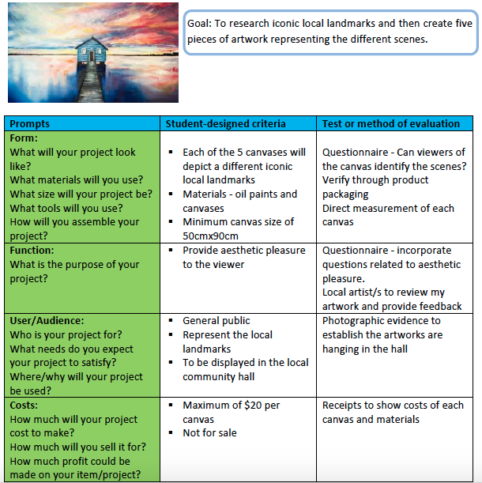

Appendix 8 – Tips for report writing

*Your report should be organized using the* ***criteria*** *and these should be used as section headings. You might also want to add further sub-headings related to each part of the criteria. The following table collects together some tips and guidance given by the IB.*

|  |
| --- |
| **How to achieve the highest levels in Criterion A (Investigating)** |
| * The goal must be very clearly stated. This is best done in its own paragraph, not hidden in the middle of one. You can talk about the evolution of your goal but make sure that the person reading your report is not hunting around trying to find the actual goal. * **“**Define**” means to give the precise meaning of something so make sure the goal contains** clarifying statements if anything is unclear. * **Explain why this project is ‘**highly challenging**’ for you.** * Explain why you chose this project. Where does your personal interest come from? Why is it important to you? * Talk about the global context in this part of your report. How does it guide your research and investigation in a meaningful way? Why did you choose to focus your report this way? * You need to be very detailed and specific about what you already know about every aspect of your proposed goal. Give examples to help. It needs to be clear that your idea stems from personal interest, but also that there is some room for growth in terms of your understanding of the topic. * In order to demonstrate research skills you need to:   + have a complete bibliography that shows you have used a wide variety of sources   + have in-text references where appropriate   + write a detailed evaluation of some of the sources you used (for example in OPVL format) |
| **How to achieve the highest levels in Criterion B (Planning)** |
| * The criteria will be used to self-assess the extent to which you achieved your goal later in the project. They should therefore reflect all the elements of the goal. It is best to take some advice from a real-life expert to decide what an ‘excellent’ outcome or product should be. * The criteria can be written in list form, or better still as a rubric. * If the project has more than 1 aspect to the goal (for example to learn something and then to perform), there may be separate criteria for the parts. * The plan should have been devised at the start of the process and should include information about any changes that were necessary along the way, with reasoning. This can then also be used as evidence of your self-management skills in a few sentences in the body of your report, or included as an extract in the appendices. * You can achieve a high level for your self-management skills by reflecting honestly on your ability to manage yourself – not just by meeting all the deadlines. It does not matter if your plan changes – the important thing is to reflect concisely on why it changed and how you used your self-management skills to adjust your planning. |
| **How to achieve the highest levels in Criterion C (Taking action)** |
| * You must put evidence of your product or outcome in your report (or appendices). * You do not need to write a detailed assessment of its quality against your assessment criteria yet – that is in the next section. But you might want to make a statement about your overall feeling in relation to its quality. Are you please with how it turned out? What might you do differently if you did it again? * Evaluate your thinking skills directly – write a few paragraphs giving examples of when you demonstrated excellent thinking skills. Put additional evidence in the appendices if necessary (but refer to it in the body of the report). * Evaluate your communication and social skills directly - write a few paragraphs giving examples of when you demonstrated excellent communication and social skills. Put additional evidence in the appendices if necessary (but refer to it in the body of the report). |

|  |
| --- |
| **How to achieve the highest levels in Criterion D (Reflecting)** |
| * Use your own assessment criteria (rubric) and be honest about the extent to which you achieved each of the strands. Give a detailed explanation of each and reflect honestly on your product. This criterion measures your ability to EVALUATE in an unbiased manner**—**not justify the grade you would like to score. * Include evidence from others about the quality of your product/outcome if you can. Did you do a survey or a test to find out what people thought? * Reflect back on your previous knowledge and describe and explain how your knowledge and understanding of the topic you researched has deepened. What did you think then and what do you think now. Why has it changed? * Reflect on the global context. To what extent do you have a deeper appreciation of it now? How did it shape your project? * Reflect on your personal development. What have you learnt about yourself? * It is VITAL that you give specific examples and evidence where possible to back up or demonstrate points that you are making. * Make this section detailed, thoughtful, reflective and specific **–**without getting flowery. * Use the appendices to show specific evidence. * Refer to the appendices in the body of the report. |

For further guidance on writing your report, see the separate guidelines attached to the ManageBac submission deadline or access them at this link: <https://goo.gl/bMQjH5>

Appendix 9 – Personal Project assessment criteria

# Criterion A: Investigating

## Maximum: 8

In the personal project, students should be able to:

1. define a clear goal and global context for the project, based on personal interests
2. identify prior learning and subject-specific knowledge relevant to the project
3. demonstrate research skills.

|  |  |
| --- | --- |
| **Achievement level** | **Level descriptor** |
| 0 | The student **does not** achieve a standard described by any of the descriptors below. |
| 1–2 | The student:   1. **states** a goal and context for the project, based on personal interests, but this may be **limited** in depth or accessibility 2. identifies prior learning and subject-specific knowledge, **but** this may be   **limited** in occurrence or relevance   1. demonstrates **limited** research skills. |
| 3–4 | The student:   1. **outlines** a **basic and appropriate** goal and context for the project, based on personal interests 2. identifies **basic** prior learning and subject-specific knowledge **relevant** to   **some** areas of the project   1. demonstrates **adequate** research skills. |
| 5–6 | The student:   1. **defines** a **clear and challenging** goal and context for the project, based on personal interests 2. identifies prior learning and subject-specific knowledge **generally relevant** to the project 3. demonstrates **substantial** research skills. |
| 7–8 | The student:   1. **defines** a **clear and highly challenging** goal and context for the project, based on personal interests 2. identifies prior learning and subject-specific knowledge that is   **consistently highly relevant** to the project   1. demonstrates **excellent** research skills. |

# Criterion B: Planning

## Maximum: 8

In the personal project, students should be able to:

1. develop criteria for the product/outcome
2. plan and record the development process of the project
3. demonstrate self-management skills.

|  |  |
| --- | --- |
| **Achievement level** | **Level descriptor** |
| 0 | The student **does not** achieve a standard described by any of the descriptors below. |
| 1–2 | The student:   1. develops **limited** criteria for the product/outcome 2. presents a **limited or partial** plan and record of the development process of the project 3. demonstrates **limited** self-management skills. |
| 3–4 | The student:   1. develops **adequate** criteria for the product/outcome 2. presents an **adequate** plan and record of the development process of the project 3. demonstrates **adequate** self-management skills. |
| 5–6 | The student:   1. develops **substantial and appropriate** criteria for the product/outcome 2. presents a **substantial** plan and record of the development process of the project 3. demonstrates **substantial** self-management skills. |
| 7–8 | The student:   1. develops **rigorous** criteria for the product/outcome 2. presents a **detailed and accurate** plan and record of the development process of the project 3. demonstrates **excellent** self-management skills. |

# Criterion C: Taking action

## Maximum: 8

In the personal project, students should be able to:

1. create a product/outcome in response to the goal, global context and criteria
2. demonstrate thinking skills
3. demonstrate communication and social skills.

|  |  |
| --- | --- |
| **Achievement level** | **Level descriptor** |
| 0 | The student **does not** achieve a standard described by any of the descriptors below. |
| 1–2 | The student:   1. creates a **limited** product/outcome in response to the goal, global context and criteria 2. demonstrates **limited** thinking skills 3. demonstrates **limited** communication and social skills. |
| 3–4 | The student:   1. creates a **basic** product/outcome in response to the goal, global context and criteria 2. demonstrates **adequate** thinking skills 3. demonstrates **adequate** communication and social skills. |
| 5–6 | The student:   1. creates a **substantial** product/outcome in response to the goal, global context and criteria 2. demonstrates **substantial** thinking skills 3. demonstrates **substantial** communication and social skills. |
| 7–8 | The student:   1. creates an **excellent** product/outcome in response to the goal, global context and criteria 2. demonstrates **excellent** thinking skills 3. demonstrates **excellent** communication and social skills. |

# Criterion D: Reflecting

## Maximum: 8

In the personal project, students should be able to:

1. evaluate the quality of the product/outcome against their criteria
2. reflect on how completing the project has extended their knowledge and understanding of the topic and the global context
3. reflect on their development as IB learners through the project.

|  |  |
| --- | --- |
| **Achievement level** | **Level descriptor** |
| 0 | The student **does not** achieve a standard described by any of the descriptors below. |
| 1–2 | The student:   1. presents a **limited** evaluation of the quality of the product/outcome against his or her criteria 2. presents **limited** reflection on how completing the project has extended his or her knowledge and understanding of the topic and the global context 3. presents **limited** reflection on his or her development as an IB learner through the project. |
| 3–4 | The student:   1. presents a **basic** evaluation of the quality of the product/outcome against his or her criteria 2. presents **adequate** reflection on how completing the project has extended his or her knowledge and understanding of the topic and the global context 3. presents **adequate** reflection on his or her development as an IB learner through the project. |
| 5–6 | The student   1. presents a **substantial** evaluation of the quality of the product/outcome against his or her criteria 2. presents **substantial** reflection on how completing the project has extended his or her knowledge and understanding of the topic and the global context 3. presents **substantial** reflection on his or her development as an IB learner through the project. |
| 7–8 | The student:   1. presents an **excellent** evaluation of the quality of the product/outcome against his or her criteria 2. presents **excellent** reflection on how completing the project has extended his or her knowledge and understanding of the topic and the global context 3. presents **excellent** reflection on his or her development as an IB learner through the project. |

Appendix 10 – Sample PP reports

In the interests of keeping the handbook to a manageable size, we provide only a link here to the sample report.

The reports linked to below were awarded a grade 7 (out of 7) by the IB and can therefore be treated as good examples. However, they were not completely faultless and you do not have to follow it’s structure or content completely. Instead, read the report and consider how it might have hit each element of the criteria – this will help you do the same in your own report writing.

**Sample report 1:**

|  |
| --- |
| **Goal** |
| To investigate the history of the Kulin Tin Horse Highway and then weld and create my own tin horse sculpture to erect on the highway |
| **Global context** |
| Personal and cultural expression |
| **Product/outcome** |
| A sculpture made from recycled materials |
| **Link to report** |
| <https://goo.gl/ISjuYm> |

**Sample report 2:**

|  |
| --- |
| **Goal** |
| To learn more about how rockets work and basic rocket science, through the means of designing and building my own model rocket |
| **Global context** |
| Scientific and technical innovation |
| **Product/outcome** |
| Building a model rocket |
| **Link to report** |
| <https://goo.gl/L3BrmH> |